Market Overview

The Manhattan office condominium segment is made up of 99 buildings, occupying a total of 10.9 million square feet. The Midtown submarket is comprised of 6 million square feet; Midtown South is comprised 2.8 million square feet; Downtown is comprised of 2.1 million square feet.

The composition breakdown by class is 3.4 million square feet of class A condominiums, 5.4 million square feet of class B, and 2.1 million square feet of class C.

First Half of 2018 Office Condominium Sales: (Blue Box)

In the first half of 2018, there were a total of 253,174 square feet of office condominium sales in Manhattan, totaling $236,501,223. The sales averaged $934 per square foot. There were a total of 34 office condominium units sold in 20 different buildings, averaging 7,446 square feet per sale.

***Square Footage of Sales:*** The total square footage of sales nearly doubled in the first half of 2018 compared to the second half of 2017 with 253,174 square feet sold in the first half of 2018 and 128,001 square feet in the second half of 2017. The total square footage of sales in the first half of 2018 is also notably higher than the five-year average of 209,514 square feet per half year.

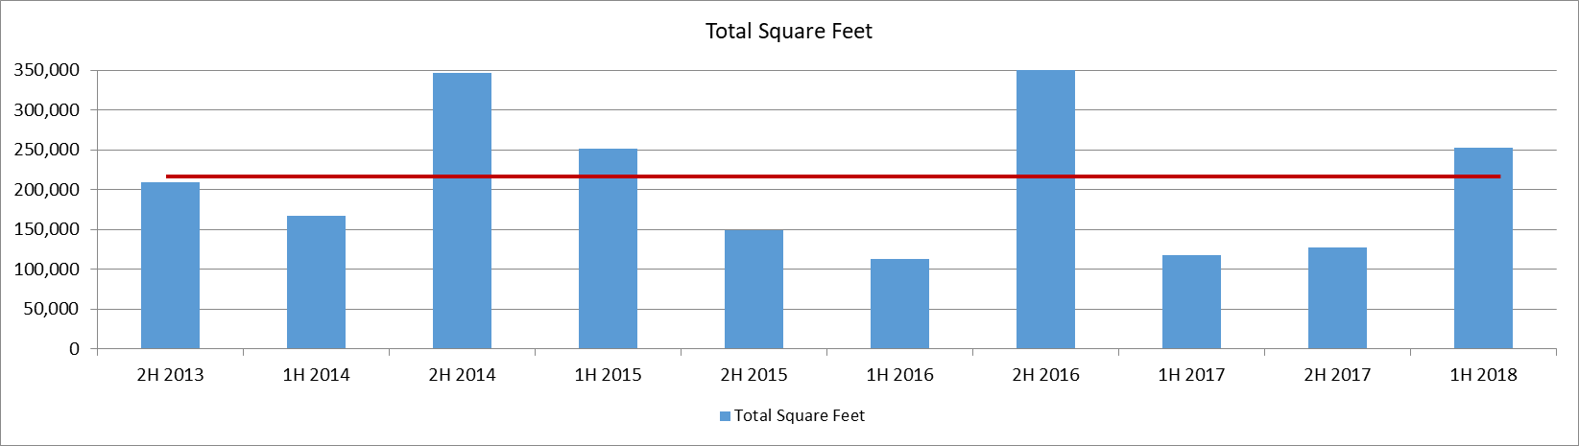

***Dollar Value of Sales:*** In the first half of 2018 there was a total of $236,501,223, which is more than double the dollar of sales in the second half of 2017. The dollar value of sales is 50% greater than the five-year average of $158,724,237.

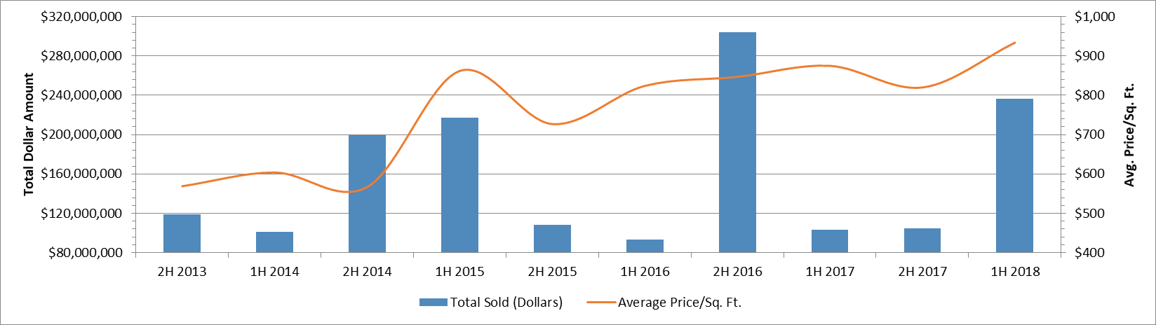

***Average Price Per Square Foot:*** In the first half of 2018 the average price per square foot was a record high of $934. Pricing was significantly higher than the previous record of $875 per square foot recorded in the second half of 2016. Pricing was also significantly higher than the five-year average price per square foot of $758.

***Number of Sales:*** There were 34 sales in the first half of 2018, compared to 22 sales in the second half of 2017. The number of office condominiums sold in the first half of 2018 was more than the five-year average by 4 sales.

Submarket Statistics

The Midtown submarket is Manhattan’s largest office condominium submarket, comprising approximately 6 million square feet. In the first half of 2018, there were 7 sales totaling 55,592 square feet. The dollar value of these sales totaled $48,283,888, averaging $869 per square foot.

The Midtown South submarket comprises approximately 2.8 million square feet of office condominiums. In the first half of 2018, there were 24 sales totaling 182,823 square feet. The dollar value of these sales totaled $175,481,775, averaging $960 per square foot.

The Downtown submarket comprises approximately 2.1 million square feet of office condominiums. In the first half of 2018, there were 3 sales totaling 14,759 square feet. The dollar value of these sales totaled $12,735,560, averaging $863 per square foot.

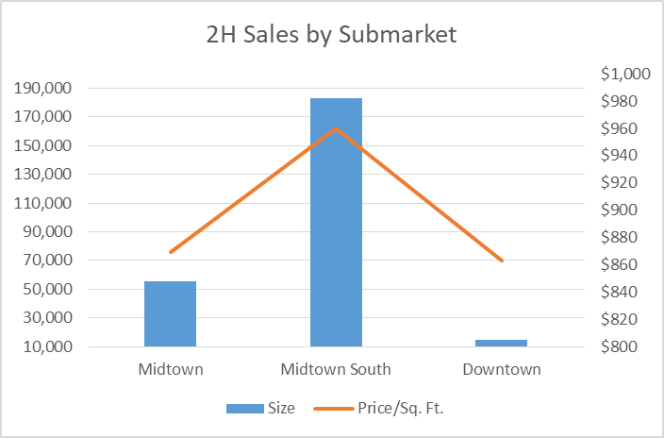

Availability

There is 813,668 square feet of available Manhattan office condominiums, which equates to a 7.4% availability rate. There are 74 units for sale in 36 buildings, with an average asking price of $1,052 per square foot. In the Midtown submarket, there is 587,357 square feet for sale, with an average asking price of $1,093 per square foot. In the Midtown South submarket, there is 49,105 square feet for sale, with an average asking price of $962 per square foot. In the Downtown submarket, there is 177,206 square feet for sale, with an average asking price of $943 per square foot. The availability rates and pricing has increased by 0.8% from the second half of 2017.

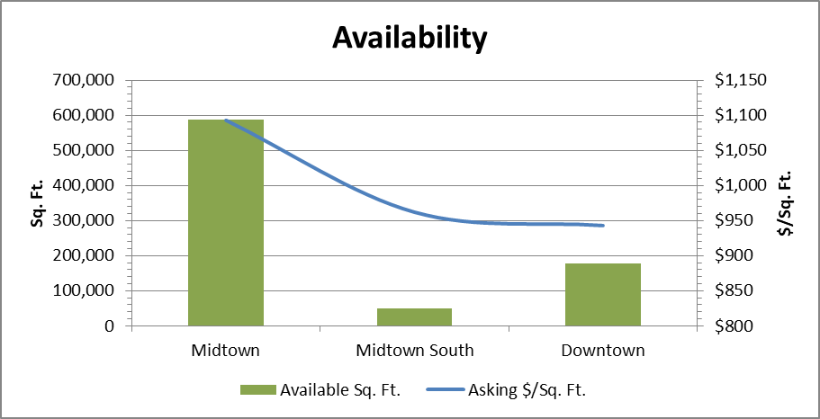

**Notable Office Condominium Sales**

250 Bowery

between Prince and Houston Streets

Entire 2nd Floor: 6,466 Sq. Ft.

Price: $9,000,000 ($1,392/Sq. Ft.)

Sale Date: 01/12/18

Purchaser: The Gerald J. & Dorothy R. Friedman Foundation, an affiliate of the East Village-based arts non-profit, Howl Arts, Inc.

Seller: VE Equities, the development firm owned by Zach Vella and Justin Ehrlich

420 Fifth Avenue

between 37th and 38th Streets

Entire 18th Floor: 17,550 Sq. Ft.

Price: $19,700,000 ($1,123/Sq. Ft.)

Sale Date: 03/23/18

Purchaser: Luxottica Group, the publicly traded eyewear company that also purchased the 16th and 17th floors in a separate transaction in June 2018

Seller: Techint, Inc. an Italian industrial company which has owned the floor since 1995

131 West 33rd Street

between Broadway and Seventh Avenue

Entire 7th Floor and a portion of the 8th Floor: 19,105 Sq. Ft.

Price: $18,059,050 ($945/Sq. Ft.)

Sale Date: 03/14/18

Purchaser: Local 79, the construction and general building laborers union

Seller: Progressive Credit Union, which still owns the remainder of the 8th floor totaling 5,031 sq. ft.

345 East 37th Street

between First and Second Avenues

Units 203 and 204: 19,200 Sq. Ft.

Price: $14,100,000 ($734/Sq. Ft.)

Sale Date: 06/07/18

Purchaser: Turtle Bay Music School, the non-profit which recently sold its building at 244 East 52nd Street

Seller: Carlyle Group and 60 Guilders, the sponsor of the office condominium conversion

421 West 54th Street

between Ninth and Tenth Avenues

Entire 2nd Floor: 14,514 Sq. Ft.

Price: $15,840,000 ($1,091/Sq. Ft.)

Sale Date: 04/18/18

Purchaser: American Musical and Dramatic Academy, a performing arts school

Seller: Music Theatre International, a theatrical licensing agency

70 West 36th Street

between Fifth and Sixth Avenues

Unit 5A: 5,428 Sq. Ft.

Price: $5,020,900 ($925/Sq. Ft.)

Sale Date: 06/04/18

Purchaser: Color Fast, a printing company that recently sold an office cooperative at 121 Varick Street

Seller: 170

# **The Rise of the Owner-Occupier**

In the first half of 2018, 93% of buyers who purchased New York office condominiums were owner-occupiers as opposed to investors.

The difference: Owner-occupiers purchase the office condominiums to use for their operating space, while investors purchase them to lease out to tenants and earn a rate of return on their investment.

The cost-saving benefits of condominium ownership are significant. Owner-occupiers will find it often costs less than leasing, especially as New York City rental rates remain at record highs. A variety of financing options make it affordable for businesses, while many non-profit and government organizations are exempt from paying real estate taxes when they own and occupy their space. Businesses can justify higher build-out costs to increase their competitive edge and value of their real estate while insulating themselves from the escalating and unpredictable costs of leasing. No longer are they subject to the whims of landlords or fluctuations of the market.

While the majority of office condominium owner-occupiers tend to have smaller footprints, larger corporations are beginning to realize these benefits and are purchasing their space for the same reasons: control over their space, long-term capital appreciation, and no longer willing to throw money away in rent.

## Recent Headline-Grabbing Purchases

The major corporate users who look to reap the benefits of office ownership have been actively purchasing both office condominiums and entire buildings over the past few years. Among them:

* Google’s $2.4 billion purchase of the 1.2 million-square-foot Chelsea Market from Jamestown. The Internet giant had already occupied a significant portion of the building, and the purchase follows its $1.7 billion buy of 111 Eighth Avenue from Taconic Investment Partners in 2010.
* JPMorgan Chase’s intended purchase of air rights from Grand Central Terminal and St. Bartholomew’s Church to pursue a new 2.5 million-square-foot headquarters building at 270 Park Avenue. The purchase would save the company money by consolidating a variety of locations into one fully LEED-certified, energy efficient office tower.
* WeWork’s $850 million purchase of Lord & Taylor’s flagship store on Fifth Avenue. After the 2018 holiday season, the co-working company will convert the building into its headquarters.
* The New School’s $135 million purchase of the 180,000-square-foot 34-42 West 14th Street from Samson Associates. It plans to turn the property into an academic building once the leases of the building’s commercial tenants expire.
* Major corporate users have been purchasing large office condominiums, including Time Warner’s purchase of 1.6 million square feet, Wells Fargo’s purchase of 500,000 square feet, and KKR & Co.’s purchase of 343,000 square feet at Related Companies and Oxford Properties Group’s 30 Hudson Yards.

Add pictures of some of these deals above